CTM-I Use Case

Generic Parm Add

Version 0.1

Use Case Name | Generic Parm Add
Actor | App Support
Pre-conditions /Assumptions | User has selected Add from the Parm Browse.
Post Conditions | User can return to the Parm Browse by selecting the “Return to Browse” link. This will return to the Parm Browse as use the user’s last criteria and sorting to display the search results.
Screenshot | 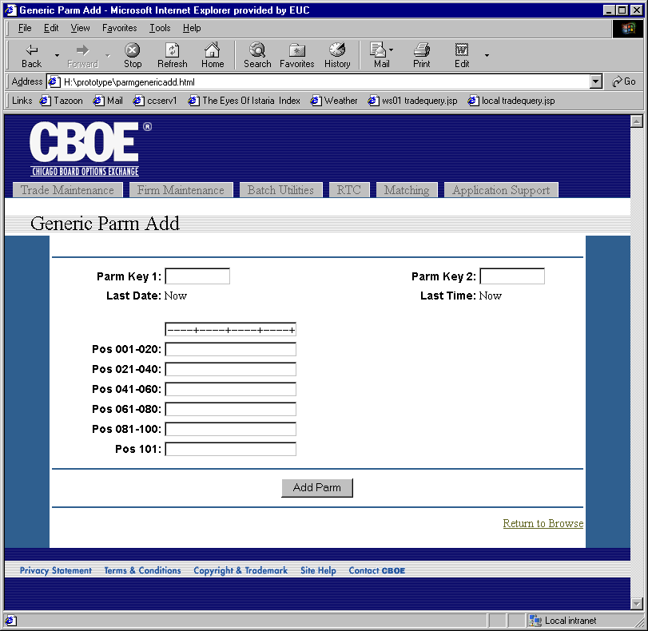
Flow of Events | - Generic Parm Maintenance screen is displayed.  - Read-Only fields are  - Last Date  - Last Time  - Parm Key 1 and Parm Key 2 fields are editable.  - Editable data field is broken into sections to make editing easier.  - User can press the “Add Parm” button to add the parm.  - The add request will be sent to CTM-R to process  - Results of the CTM-R processing will display on the screen.
Alternative Path

